GAD323 Readings & Assignments: Week 1

Week 1 Reading
Complete the following reading early in the week:
- Week 1 online lectures
- The following chapters from the text Storyboards, Motion in Art (3rd Edition), by Mark Simon:
  - Chapter 5: Materials
  - Chapter 11: Presentation Boards versus Production Boards
  - Chapter 13: Animation Boards
  - Chapter 14: Gaming and Multimedia Boards
  - Chapter 17: Comps
  - Chapter 18: Animatics
Week 1 Assignments Overview
Assignment Summary: | Due Date
Assignment 1: Autobiography | Friday, May 15, 2009
Assignment 2: Discussion Questions | Saturday, May 16, 2009
Assignment 3: Final Project: Storyboard Proposal | Tuesday, May 19, 2009
Assignment 4: Final Project: Initial Designs | Tuesday, May 19, 2009
Remember that all assignment details can be found on the assignment pages located throughout the week. Go to those specific pages for direction on how to complete each individual assignment.

Welcome
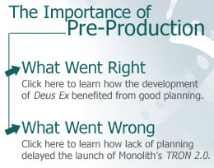
Hello and welcome to Layout and Scene Design!
The preproduction phase is essential in any production, whether films, animations, or games. This is the phase when the look of the characters and environments is decided, the continuity of the piece is solidified, and the camera angles and staging are designed for maximum emotional impact. This phase provides a blueprint of the final product through storyboards, model sheets and other elements created during this phase, ensuring the smooth running of the project.
Such a plan also allows you to execute changes quickly and fix potential problems before they arise in the production phase. After all, it's far easier and cheaper to fix problems in sketches than to fix them after an army of animators has already worked on the scene. Therefore, even though the work for layout and scene design comes before the actual production, many consider layout artists to be directors.
In this course you will create rough sketches and final production stills, storyboards, and matchlines for a final layout package. Starting now, you will also analyze films and video games for frame composition, staging, and scene design; this will help you in your Final Project. From this course you'll take away a layout package containing these items:
- Presentation for layout (cover folder titled consistently and neatly labeled with name of student, name of project, and date at the head of all elements)
- Storyboard (in color, with camera notes, animation notes, and script attached to appropriate panels)
- Prop sheets (with designs for all of the important props in the script)
- Background treatments (full-color background pictures for all backgrounds)
- Character model sheets (full-color with line up of all characters on one page, then additional pages with three to eight action poses of each individual character)
- Camera shots
- Scene breakdown (a scene-by-scene breakdown which matches background, camera notes, props, characters, and other essentials for animating. You may present this in a written form as a chart.)
- Matchlines (consisting of storyboard with arrows notating screen direction and eyelines)

Characteristics of Film and Video Games
Both films and video games are defined by unique characteristics that include frame composition, staging, sound design, and editing. Not every production employs all these characteristics at once—some video games don't use editing at all—but these are the characteristics most commonly used in productions. Let's see what these characteristics are all about.
Imagine you had to shoot a scene with a woman sitting on a couch and talking on the phone. How would you compose the frame? Would you have a straight ahead shot with the woman in full frame, a close-up, a high or low angle shot, or something else? This is where the concept of frame composition comes in. Frame composition can include camera angles, lens attributes, lighting, and placement of objects. In many cases the composition of the frame might be dependent on the content, but creating dynamic compositions for each scene can enhance the visual impact of a scene.
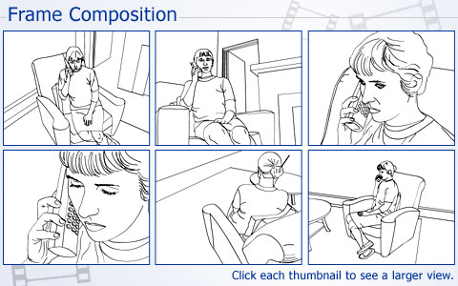
Consider this: Will you film the woman from the back so that her face isn't visible? If your scene starts with her walking into the room to answer the phone, how would you stage her path to keep her visible in the frame and not detract from the story? Enter staging—the technique of placing and moving actors through the frame. Some of the concerns of staging are important for making the story clear, others are important for making the shot dynamic.
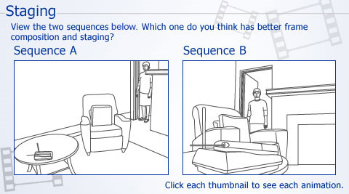

Learning Outcomes:
- Critically evaluate video games.
- Reconstruct a film or animation sequence to determine its structure.
- Demonstrate the use of correct terminology and formats associated with preproduction instructions.
- Create thumbnail sketches of concepts that utilize narrative structure, editing, shot composition, aesthetics, and continuity.
- Keep an Idea Journal and sketchbooks in preparation for thumbnails and model sheets for all projects to establish professional preplanning skills.
- Develop skills using pens, markers, colored pencils and other media to create professional presentations and animation storyboards.
Apart from enhancing the overall feel of a piece, the sound you choose goes a long way in telling your audience how to respond to a scene. Sound design can carry up to 70 percent of the emotional impact of a film or video game. Imagine a scene where a character is shooting at the villains. The scene would be approached differently if the character used a machine gun, rather than a handgun.
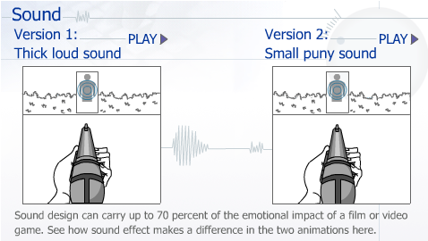
Editing refers to any cuts that are made between various camera angles and between scenes. Since the birth of cinema, editing has been described as the one aspect that is uniquely a part of films. It is because of this invaluable technique that we can see a scene composed of disparate shots of people's faces talking, and in our minds, we put them together so that we perceive them as happening simultaneously.
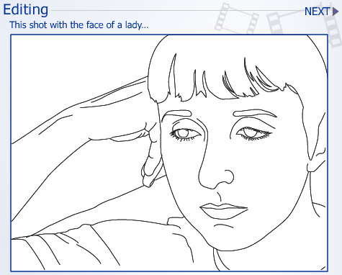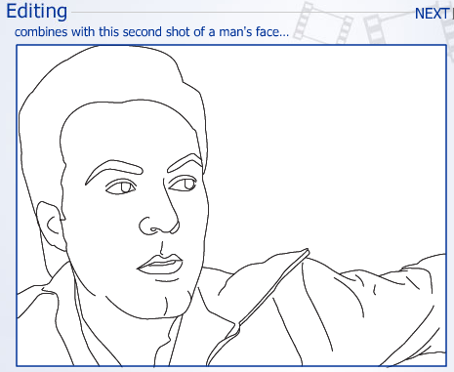
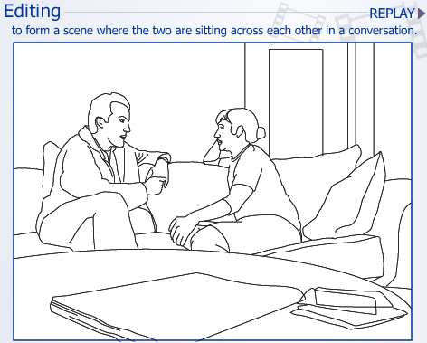

Elements of a Layout
While understanding the characteristics of films and video games will enable you to look at films analytically and critically, you also need to be familiar with the elements of a layout—a variety of preproduction strategies that assist in isolating and developing these characteristics.
A typical layout package consists of several elements, the importance of which is decided by the need of a specific production. You may choose not to use some elements at all, and some elements all the time. You may even have to create something new to fulfill the particular needs of a project. Here are some of the layout elements that are often used:

Elements of a Layout Package:
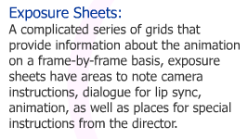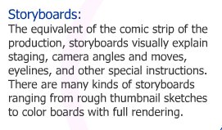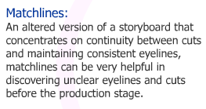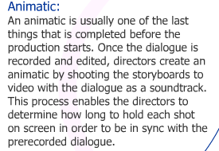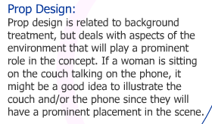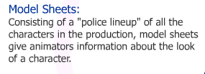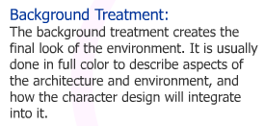

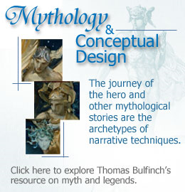
Conceptual Design
When you see a film or game in its final form, you will find it both difficult and fascinating to imagine how it all started, and what processes lead to the polished product that you see. At the inception of each production—often before a contract is signed and the crew is hired—lies the original seed of an idea. Conceptual design, therefore, is usually one of the most intuitive aspects of a production, and easily one of the most misunderstood!
Most people think that some artists have an uncanny ability to come up with ideas, a natural talent that can't be taught. They think of drawing in the same manner. Nevertheless, conceptual design, like any other aspect of animation, can be approached strategically. Some of the most prominent ways of creating concepts are based on dreams, personal history, mythology, appropriation, adaptation, or documentary.
Bullfinch Mythology website: http://www.bartleby.com/bulfinch/

Dreams
Our subconscious mind offers a wealth of creativity. We spend a third of our existence sleeping, and our dreams comment on our life in a way that isn't possible to analyze. While dreams often aren't logically structured in a way that can be used for conceptual design, they do give us interesting scenarios and metaphors that can become the seeds for fascinating stories.

Memories
Your biggest asset for conceptual design is your memory. A memory of being teased as a kid, a fishing trip with your grandfather, or a romantic relationship from your youth can be a great place to mine ideas for stories. And it isn't just your own personal experiences. Perhaps you have a memory of a student giving a presentation in high school when the floor of the stage gave way and broke down. While you may not have experienced some incidents directly, any observations you made and feelings you had at the time are important as well.

Mythology
Mythology holds a wealth of possibilities for conceptual design. The film O Brother Where Art Thou is based on the Greek myth of Ulysses. Of course if you watch the film, it doesn't seem like a myth, but the underlying story structure is the mirror image of Ulysses. Other mythology and religious stories can be mined for ideas as well. Joseph Campbell's book The Hero with a Thousand Faces is a great resource for understanding the relationships between these stories.

Appropriation
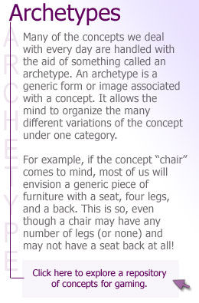
Appropriation is the art of taking an idea from a source (much like adaptation), and filtering it through your mind and giving it your individual voice. While adaptation is usually based on literature (novels, short stories, poetry, nonfiction, and so on), appropriation can be based on anything.

Adaptation
Using adaptation, it is your responsibility to maintain the story. With appropriation, the story inspires you to develop your own idea. A painting, an advertisement, or even a radio announcement might spark your interest and lead to a unique story idea. The important thing to remember about appropriation is how to use a resource as inspiration without any infringement on copyright. You must change the original concept significantly rather than just copying it.
Adapting a story from a previous source is a great way to find ideas. There are millions of story ideas that can inspire films, animations, and video games. The other advantage of adaptation is that it gives you something specific to begin work on—the plot, characters, and even some of the dialogue is already done before you begin the production. This gives you more time to find the best way to visualize the story.
Another way to use adaptation is to find documentaries or other nonfictional resources and develop them as fiction. News stories are a great source of inspiration.
Indeed there are as many approaches to conceptual design as there are writers creating ideas. In your career, you will often be asked to create proposals. Your knowledge of conceptual design will ensure that you are never at a loss for ideas!
Repository for ideas: http://www.gamediscovery.com/

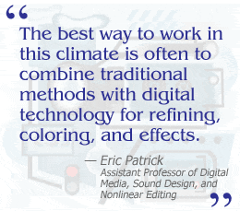
Storyboard Creation Tools
For the purposes of this class, you are welcome to use your favorite tools to create your storyboard and layout packages. You can use markers or pencils for drafting on paper, or you may prefer creating your artwork directly in Photoshop or Illustrator. Whatever you choose, it is important that you scan all your artwork into a convenient digital format for easy editing and final presentation.
Initially, you should create many drawings. Draw quickly to work out angles and rough, graphic compositions. For this stage, you'll find using pencil or charcoal on paper the quickest and easiest way to sketch, and the best way to keep your drawings loose and fresh. After making your initial design, redraw each character and storyboard panel repeatedly, revising and refining the balance between the individual compositions and the various panels.
As you continue to refine your storyboard, character designs, and other layout elements, you can add color with markers or scan your drawings into the computer to color. Photoshop is a great computer tool for adding color and definition to sketches, allowing you to blur and add lens flares and other visual effects easily without affecting the original drawing.
Many people still prefer to work traditionally from start to finish (see storyboard artist interviews in your text Storyboards: Motion in Art). While this is perfectly acceptable in most professional situations, storyboard jobs are becoming increasingly digital, making the understanding of computer graphics an essential element. The best way to work in this climate is often to combine traditional methods with digital technology for refining, coloring, and effects.

Conclusion
This week you identified the characteristics of films and video games, and also learned about the various elements of a layout. You traced the development of ideas from sources as varied as dreams and myths to personal experience and memory. Your reading of staging and frame composition will help you next week when you will draft a storyboard and design video game layout.

Postmortem: Monolith’s TRON 2.0
By Frank Rooke
Gamasutra
September 10, 2003
URL: http://www.gamasutra.com/features/20030910/rooke_01.shtml
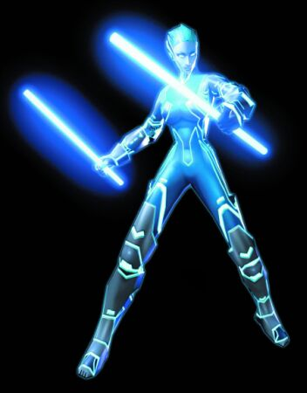
Mercury, jet cycle champion of the digital world.
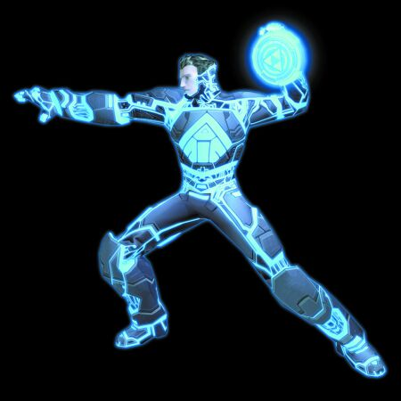
Our intrepid hero, Jet.
From the start, it didn’t take long for many of us at Monolith to recognize that a TRON project was a once-in-a-lifetime opportunity, not simply because we believed the film would lend itself to great gameplay, but also because of the movie’s status as a
cultural icon. As a high school student at the time of the original theatrical release, I remember it piquing my interest in computers and videogames. Whether at the time I fully realized the film’s impact or not, it certainly planted seeds that flourished later in my life. Since the start of the project, I’ve spoken to many people about TRON, and I repeatedly get the same kind of story: “It’s why I’m into computers,” “It’s why I’m into 3D graphics,” “It’s why I’m into gaming.”
When Buena Vista Interactive, the core games publishing label of Buena Vista Games, approached Monolith with the TRON project, they were quite up-front about the challenges facing the franchise. While everyone readily agreed it would make a great computer game, generating interest for a title based on a 20-year-old cult classic film that was released ahead of its time might be difficult. Regardless, the project moved forward with great enthusiasm from both Monolith and Buena Vista Interactive. The fact that the game could possibly pave the way for a new TRON film and reignite the franchise was very exciting, injecting a unique motivation into the project that Monolith didn’t take lightly.
Overall, TRON 2.0 is a first-person action game that takes place in the digital universe established by the 1982 film TRON. It’s important to note that the game does not follow the events seen in the film. Instead, it is a spiritual sibling, or something of a sequel. The core premise of a society mirroring our own that exists in the computer remains intact, as does the phenomenon of a human transporting (or digitizing, as we say in the game) into the computer. Beyond that, the TRON 2.0 universe breaks new ground. Analogies, metaphors, and social consequences reflect how we understand and position computers in our lives today as well as where they may be in the near future. The game tells only one story of a hundred possible stories, making the TRON universe much like the Star Wars and Star Trek universes in that respect. It’s this singular quality that makes the TRON franchise timeless.

What Went Right
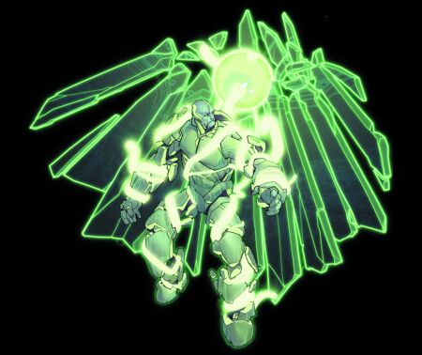
Concept art for the character Thorne.
1. Publisher compatibility. It was and continues to be a real pleasure working with Buena Vista Games. We were initially concerned that the constraints of the license would be overwhelming, with minute-level detail examination leading to a potentially watered-down game. However, it was just the opposite. While BVG had great input of their own, they encouraged us to run with our ideas. This freedom afforded us the confidence to pursue a game design without the fear of it changing or being altered in some obtuse fashion down the road.
Another peripheral benefit was the publisher’s strong international standing. There are BVG regional offices across the world. Particularly noteworthy are those in Europe. From the onset of the project we had direct contact with the very people involved with press, retailers, and consumers across multiple European regions. From a design point of view, this exposure to non-U.S. markets was enlightening and useful. It’s impossible to be all things to all people, but it is good design practice to consider the entire breadth of your target audience. TRON 2.0 is more accessible and dynamic because of it.
Lastly, BVG granted us access to the talent involved in the original film. On the art side, we were fortunate enough to meet with Syd Mead near the beginning of the project. He shared with us many of his original TRON sketches and paintings. It was a unique opportunity to learn firsthand the design philosophy behind the highly recognizable elements of the TRON world. In a sense, it allowed the TRON 2.0 artists to pick up were the film left off. Although the game achieves an overall look that is more detailed and colorful than the film, the consistency in the overall aesthetics between the two projects remains credible. Mead also contributed the new super light cycle, an exclusive design just for the game. Both Monolith and BVG agreed that it seemed appropriate, not to mention cool, to have the creator of the original light cycle design the next incarnation of the iconic bike.
Besides Syd Mead, the team had access to special effects director Richard Taylor and TRON creator Steven Lisberger to review progress of the game. Taylor, on one occasion, popped into the Monolith office and provided some very helpful feedback regarding lighting and camera movement. On the acting side, Bruce Boxleitner and Cindy Morgan lent their voices to the game. Most notably, Boxleitner reprised his role as Alan Bradley.
2. Identifying iconic elements from the film. We asked ourselves, what were the core elements that provided TRON with its unique identity? Not surprisingly, we immediately isolated the disc and light cycle as iconic elements from the movie and marked them as mandatory features for the game. However, once we started looking past the obvious, we were a taken aback by the sheer quantity of other essential TRON components. To compound the issue, it became evident that different people - meaning various people on the team, at BVG, in the press, and at TRON fan sites - all isolated different elements or events from the movie as true TRON moments. What began as a simple checklist became a forum of discussion that never really concluded until the completion of the game.
To get a handle on the situation, we started prioritizing signature TRON components by how they supported gameplay and to what extent they propagated the TRON identity. We then discussed how to mature these concepts to meet the demands of a contemporary game. What we ended up with is a working mix of old and new - recognizable yet fresh. The combat component of the game still revolves around the disc, but it can now be upgraded. Environments retain the glowing, outlined look but with increased vibrancy and complexity. The story is new but resembles the original through the use of playful analogies, techie metaphors, and light-hearted humor - all hallmarks of the original script. And finally, memorable entities such as Bit, Tanks, and Recognizers make appearances but with altered functionality to represent the passage of time.
We avoided simply translating the film directly into a game. It took significant effort to advance the TRON universe beyond the safety of the film. Setting out to improve iconic elements is always risky, but as a team we agreed not to take the easy road and shortchange the property’s potential by doing the bare minimum. Solely relying on the TRON name to sell units was not our strategy.
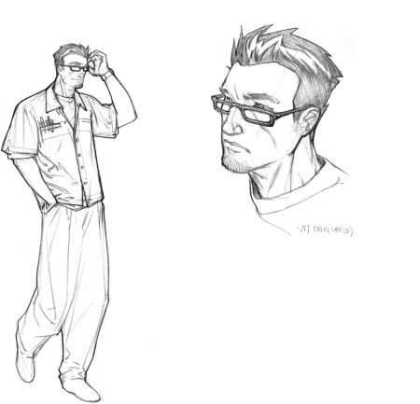
Concept art for Jet in the real world.
3. No movie license curse. It’s a common belief that movie license-based games are substandard. How many times do we see game reviews with the comment “Game X is just another mediocre game based on a movie.” We did not want TRON 2.0 to be another movie tie-in casualty. Not only would it be bad for Monolith’s reputation, but we genuinely didn’t want to waste the opportunity. TRON 2.0 needed to be able to stand on its own as a fun, engaging, and intelligent game, regardless of its lineage.
To help realize this goal, we began work TRON 2.0 as we do all our projects by reviewing successes and failures in our previous titles or similar titles so we could learn from past errors. TRON 2.0 is fully contextual to the TRON universe yet iterative relative to past Monolith efforts. With solid game design fundamentals learned from past projects, we were left free to explore unique game mechanics, storytelling devices, and technical enhancements that pushed TRON 2.0 into new territory.
4. Sharing code. The TRON 2.0 team found itself in a unique position. The No One Lives Forever 2 (NOLF 2) team was roughly eight months ahead of the TRON 2.0 schedule. They carried most of the burden of developing Jupiter, the next-generation game systems and tools needed to make NOLF 2 a cutting-edge game. TRON 2.0 was slated to closely follow NOLF 2 and directly use the Jupiter engine.
Although there were trade-offs, sharing code development with NOLF 2 primarily allowed us the freedom to focus a greater amount of our resources toward content, new features, and gameplay. TRON 2.0 certainly had its share of engineering hurdles, such as the glow effect, light cycle technology, and of course the engineering to support all of TRON 2.0’s varied game objects. However, we didn’t have to worry about creating a new renderer or AI systems. Also, uncertainties that are usually attached to new technologies were for the most part already resolved. We simply learned the parameters of the engine and adjusted the scope of our game to fit.
5. Evolved art direction. TRON 2.0 has received praise for its colorful architecture, glowing streams of energy, and creative level design. Without a doubt, the artists and level designers on the TRON 2.0 team successfully captured the essence of TRON. Not only do the characters and environments look like those found in the movie but in some cases surpass them. The art direction of TRON 2.0 really stands out as one of the primary attributes of the game, especially with the recent trend toward hyperrealistic military games. TRON 2.0 is a fresh alternative.
The method the art team used to achieve the look of TRON 2.0 was grassroots in nature. During preproduction, the artists re-created many of the actual sets from the film to get the feel for TRON. From there, they evolved the look to represent how computers changed over the last 20 years. It’s interesting to note that keyboards, monitors, and circuit boards have changed little over the years. But TRON is not about the literal interpretation of computers; it’s about the abstract world inside, the world of programs, data, and energy. It is here where more significant advancements have been made, and translating that into three-dimensional architecture was the greater challenge. Unlike building recognizable architecture, such as a warehouse or a subway, the artists and level designers had to develop the means to communicate through an abstract language to express what a firewall or PDA looked like to a program.
The film also had a distinctive glow about it. Initially, we attempted to build the glow directly into the art by using layers of additive textures. However, that proved to be time consuming and somewhat inconsistent. Plus, it was not a practical solution for characters. Collaboration between Monolith and Nvidia engineers produced a technique that generated a glow effect that was processed in real time by essentially applying a second render pass with a blurred effect. Once we saw this for the first time, it was clear TRON 2.0 was going to have a very special look. The glow effect immediately became an item of note when discussing the game with the press.

What Went Wrong
1. Short on initial resources. TRON 2.0 got off to a pretty good start. A lot of enthusiasm, ideas, and excitement flowed through the office. However, the majority of the team was still busy wrapping up other projects, and only a core team of about four or five actually began preproduction work on TRON 2.0. This is a pretty common scenario for most developers. The pacing of production usually has a small team jump-starting the next project by writing documentation, doing concept art, prototyping, and so on. Unfortunately, we failed to recognize a few issues that caused ripples later on in the production. These are lessons that we definitely plan to implement into future projects.
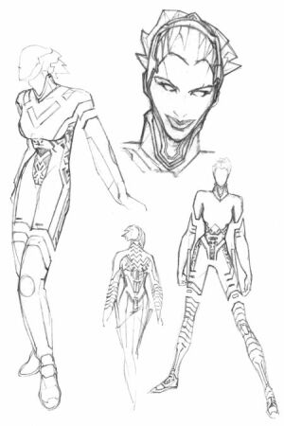
Concept art for the Mercury.
The most obvious was the lack of ramp-up time - not just in skills needed to use the new tools, but also in the mentality and spirit of the project. Past Monolith projects have been founded in more easily understood worlds. TRON 2.0 was different. It actually took some time and effort just to wrap our brains around what was TRON 2.0’s reality. When production officially started and the entire team was in place, there were quite a few months where output was minimal.
Also, the team’s understanding of the game design was affected. Scads of design documents were written up in an effort to explain the concept of the game to the team. This worked to some degree, but was not ideal. Simply telling the team what to do not only failed to tap into the wealth of talent they had to offer, but also created a division in their perception of investment. Being involved during the inception of an idea, or actually being the one who spearheads the idea itself, fully invests a person into that idea. It’s key to have the entire team feel personally attached to the project and not just see it as a series of tasks to be completed.
We did have team meetings throughout the preproduction period, and it’s not as if the design was written in a vacuum, but communication could have been better. The ownership of the design should have been more team oriented from the beginning rather than something they had to grow to accept over time.
2. Levels unplayable until later in project. It wasn’t until very late in the schedule that the team was able to experience a full, playable level. Fortunately, the gameplay came together nicely and in some cases exceeded our expectations, but it would have been a disastrous situation had it not. Why it took so long for the game to hit its stride may again be attributed to our underutilized preproduction period.
As I mentioned in the previous section, it took the team a considerable amount of time to “find” TRON - to collectively drive toward a unified vision. We had the necessary talent, and there was no shortage of ideas or inspiration, but the caliber of game we wanted to make was elusive at the beginning. In addition, TRON 2.0 pre-production did not include a fleshed-out prototype. Light cycle racing, disc combat, and the functionality of the subroutine system all loomed as unknowns for too long. To benefit fully from a good idea is to learn how to exploit it. Having key components of our game remain unknown generated trepidation when it came to linking time and resources. When the game finally did come together and we could see firsthand what worked well, we had very little time to build and expand confidently on those successful game mechanics.
3. Linking projects. Under “What Went Right,” I mentioned that TRON 2.0 benefited greatly from the fact that we used the Jupiter system, which was developed and tested during the production of NOLF 2. This was true, but there were a few hurdles that also had negative impact on production.
Although the Jupiter systems were extremely flexible, and even more so now, at the time they were tailored for a more realistic game like NOLF 2. To alter or add functionality for the TRON 2.0 project meant lots of tweaking. In addition, the team preferred to limit changes to game code, rather than rewriting core engine components unless absolutely necessary.
4. Loose review process. During our internal postproject evaluation, one topic that consistently cropped up was the inadequacy of our internal review process. Multiple elements drive the production of any project: an individual’s task schedule, the milestone schedule with the publisher, the E3 demo and press schedule, and finally the team’s internal progress evaluation. In a lot of ways the team’s own evaluations can be the most critical, and it is here that TRON 2.0 suffered some bumpy times.
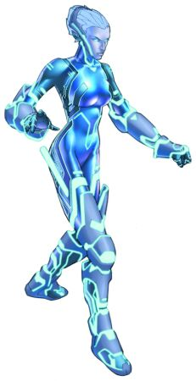
Final art for Mercury.
In the beginning, we had in place a rather loose review system. It served the purpose of keeping the team on schedule to meet the necessary publisher milestones. What it failed to do was verify the project’s overall quality and playability in a timely fashion. It was a strange sensation knowing that we were progressing according to the schedule but worrying deep down that we may not be hitting the mark. We eventually started to evaluate closely the work done by each team member at regular intervals, creating priority lists of subtasks that we felt were necessary to complete before the scheduled task could be crossed off. Toward the final third of the project, we had in place a very comprehensive review process that included weekly and sometimes daily reviews, a cross feedback system from all disciplines on the team, and an aggressive commitment not to falter, regardless of everyone’s tight schedules.
Establishing a strong internal review system was so beneficial during the final stretch of TRON 2.0 that it is now one of our primary management goals for our next project.
5. Commercial 3D software woes. Level design reached a crossroads during the production of TRON 2.0 when we began using a commercial 3D package to construct our levels. The increased power and flexibility allowed us to model and texture the unique environments found in the game. However, abandoning our game editor during this phase of construction presented gameplay-related issues later in the project.
In the past, constructing the world in our proprietary game editor allowed us to bounce back and forth easily between building and testing. When working strictly in a commercial package, the testing of work required the designer to jump through a few hoops to test work. While not overly complicated, it did require time, and therefore testing was done less frequently. Consequently, levels had problems regarding scale, flow, polygon counts, and delayed functionality - all things that could have been easily checked and verified in the game editor.
A great deal of time was lost reworking levels to make them playable. Fortunately, now that our designers are more in tune with the workflow between commercial tools and our game editor, this issue is mostly a thing of the past.

End of Line
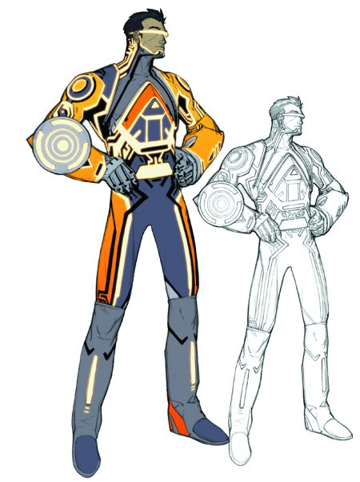
Initial concept art for Jet, it was eventually abandoned for the more heavily armored blue look.
One of the more remarkable things about TRON 2.0 is how an eclectic group of individuals came together and weathered many storms to prevail, not with just a finished product, but one of which we can be proud. The dedication and talent the team displayed excites uslooking ahead to our next project.
As far as the game itself in concerned, TRON 2.0 was truly the opportunity of a lifetime. I was personally unprepared for the amount of enthusiasm TRON 2.0 garnered from fans and from the press, both in North America and in Europe. We knew all along it was going to be a huge responsibility bringing the TRON franchise into the 21st century. Now that all the hard work is behind us, it’s a thrill to know that what we’ve accomplished can potentially be the seeds from which future projects can grow. And as a huge fan of TRON, I can’t wait to see the next tale told inside the world of computers.
Copyright © 2003 CMP Media Inc. All rights reserved.

Game Data
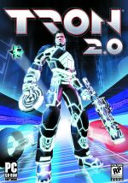
TRON 2.0
Publisher: Buena Vista Interactive
Number of full-time developers: 21
Number of part-time developers: 4 - 5 pulled in as needed plus the use of Monolith’s internal sound, music, and motion capture facilities and personnel.
Contractors: Cinematic music scoring, motion capture actors, voice actors
Length of development: 2 years
Release Date: August 26, 2003
Target Platform: PC
Development Hardware: Pentium 1.0 - 2.0 GHz machines with 256 - 512MB RAM, GeForce 1 - 4 video cards
Development Software: Lithtech DEdit/ModelEdit, Microsoft Visual Studio (C++), Photoshop, Maya, Editplus 2
Notable Technologies: Lithtech Jupiter Development System
Project Size: 2,400 files, 853,300 lines of code

Assignment 1: Autobiography
By Friday, May 15, 2009 write your autobiography containing the following details and post it to this Discussion Area:
- Name
- Expectations from the course
- What fascinates you most about animation layout and scene design? Why?
- Share examples of your favorite animation sequences from movies and video games. What specific things appealed to you in the backgrounds of these scenes and why?

Review and comment on the autobiographies of other students by the end of the week.
Assignment 1 Grading Criteria and Respective Point Value: | Maximum  Points
Construction and presentation of personal autobiography. | 4
Participation in introductions/discussions with classmates. | 4
Included their ideas on animation layout and scene design | 4
Mentioned what they appreciated about the backgrounds of their favorite animation sequences. | 4
Total: | 16
For assistance with any problems you may have when completing this assignment—OR—to offer your assistance to classmates, please use the Problems and Solutions Discussion area located through the left side navigation link.

My bio...for newbies
My history is very broad as I have traversed many a path....often bumpy. I was born in Utah and grew up in New York State and have lived pretty much all over the US of A.... My experiences have involved outdoor leadership/survival skills, horses, painting houses, gardening, making slate furniture, silk painting, pueblo pottery & waitressing in the biggest country night club in New Mexico. One day, I realized my true path and enrolled to study Fine Art at the University of New Mexico in Albuquerque. My emphasis was Photography, Printmaking, Book Arts, small Metal sculpture and Ceramics. I love working with mixed media and experimenting...so, it was only natural, and something of a pre-destination, to springboard into the digital arena.
My MFA is in Computer Art/3D Modeling and Animation, trained for the Entertainment Industry (visual effects, texturing and lighting, animation....Offered an opportunity to teach, I have been teaching Digital Art for the last 6 years, including Maya Dynamics, Houdini, Advanced production projects, Adobe Suite, Dreamweaver etc....My all time favorite program is a compositing program, Flint/Effect. Given all that...primarily, I consider myself a catalyst for fostering creative growth....a creative mentor guru, of sorts.
On a personal note, I have 3 draft horses: a Percheron, and 2 Clydesdales, Miracle, Harry and Breezy, a great cat named Emma....and my quantum physics guy named Don.
Best wishes
Kim
Assignment 2: Discussion Questions
By Saturday, May 16, 2009, go to this Discussion Area and post responses to 2 of the discussion questions assigned by the facilitator. All discussion questions should be posted to the appropriate topic in this Discussion Area.
Before the end of the week, begin commenting on at least 2 of your peers' responses. You can ask technical questions or respond generally to the overall experience. Be objective, clear, and concise. Always use constructive language, even in criticism, to work toward the goal of positive progress. Submit your responses to the appropriate topic in this Discussion Area.
Assignment 2 Grading Criteria and Respective Point Value | Maximum  Points
Response Criteria
Met the criteria for the correct responses to the questions assigned. | 4
Used vocabulary relevant to the current week's topics—at least four terms. | 4
Participation Criteria
Used vocabulary relevant to the current week's topics—at least four terms. | 4
Participated in the discussion by asking a question, providing a statement of clarification, providing a point of view with rationale, challenging a point of discussion, or making a relationship between one or more points of the discussion. | 4
Justified ideas and responses by using appropriate examples and references from texts, Web sites, and other references or personal experience. | 4
Total: | 20
For assistance with any problems you may have when completing this assignment—OR—to offer your assistance to classmates, please use the Problems and Solutions Discussion area located through the left side navigation link.
Complete both questions in one response. Provide feedback to 2 of your peers.

1. You are now about to begin this course. What are your general expectations from this course? Remember to consider the following points while responding to this question:
- How you think Animation Layout and Scene Design will help you achieve your career goals.
- The help you will need from your facilitator to achieve these goals.
2. Which games do you think best showcase the current layout trends in video game development? Pick any two games and substantiate your response with adequate reason.
The takeaway from this course comprises a complete layout package with storyboard, prop sheets, background treatments, character model sheets, camera shots, scene breakdown, and matchlines. Termed as the Final Project, you will work on it weekly, finally submitting it in Week 6.
As your Final Project needs to follow given specifications and forms a part of your portfolio, how will you ensure that your project is different from other students' and doesn't seem as if it's created in the "factory mode"? Take this opportunity to tell your classmates what you envision for your Final Project and how it will be unique and highlight your talents!

Assignment 3: Final Project: Storyboard Proposal
By Tuesday, May 19, 2009 create a proposal for your final storyboard layout package and post it to this Discussion Area. Focus on creating a script that captures the spirit of your concept and presents the vision clearly. Your storyboard proposal may be based on any of the following ideas:
- Treatment for a game
- Animation based on a short script
- Story
- Personal history
(Remember to provide appropriate treatment to your idea based on the vision and look you have decided for your storyboard.)
Note: You will be developing the complete storyboard layout package for a video game as part of your final project for this course. Therefore it is recommended that you take a great deal of time to consider a variety of ideas to be converted into a complete layout package. Select an idea that will best present your talent and skills. Remember that you will be required to review the storyboard proposals of your peers in the coming weeks.
In your storyboard proposal, pay attention to the treatment of narrative structure, editing, camera placement, shot composition, separation, and staging as elements that will enhance the storyboard.
Assignment 3 Grading Criteria and Respective Point Value: | Maximum  Points
Submitted an idea for a storyboard that has the potential for video game development. | 4
Adhered to the principles of layout for game design. | 4
Presented an original vision and look for the storyboard idea. | 4
Provided appropriate treatment to the idea based on the vision and look decided for the storyboard. | 4
Total: | 16
For assistance with any problems you may have when completing this assignment—OR—to offer your assistance to classmates, please use the Problems and Solutions Discussion area located through the left side navigation link.

For clarity: Storyboard Proposal
Please create a proposal for your final storyboard layout package and post it to the Discussion Area. Focus on creating a script that captures the spirit of your concept and presents your vision clearly. Your storyboard proposal may be based on any of the following ideas:
Treatment for a game
Animation based on a short script
Story
Personal history

Here is a link that explains the process that you are about to create.
The proposal will state the overall storyline, the characters, time period, environment, and other details. I hope this helps.
http://www.mcli.dist.maricopa.edu/authoring/studio/guidebook/storyboard.html

Sample scripts:
http://www.script-o-rama.com/table.shtml

Consider @ 30 seconds for the scene = 12 - 16 shots
I've posted an exmple final in Doc Sharing under Examples

use this layout:
Treatment:
•Title:
•Genre:
•Player mode:
•Time interval:
•Premise (or high concept):
•Back story:
•Synopsis:
•Storyboard:

SAMPLE:
Jennings_GAD323_WK1_A3
Treatment:
- Title: Death List (Working Title)
- Genre: Third Person Action/Adventure
- Player mode: Single Player
- Time interval: Real Time and/or Time Limited, depending on the mission/situation.
- Premise (or high concept): In a world where the innocent suffer and the guilty roam free, two assassins take a stand for what's right. Take out your targets across globe in 30 heart-stopping missions using stealth and the latest technology. Stop at nothing to the strike fear in the hearts of evil around the world and complete your, "Death List".
- Back story: Before the game ends, the gamer will be taken on a journey across the globe carrying out assassinations on a list of targets. The two main characters carry out their missions using high tech gadgets. Their story lines cross and they team up as the story begins to unfold. The list of targets has a connection which may change the course of history and puts mankind at risk. The player will use state of the art weapons and use their superior intelligence, agility, and speed to complete their mission. The game moves at a break neck pace to its exciting climax. Will mankind survive the carnage?
- Synopsis: The player will first be introduced to the main characters in the beginning title sequence and cut scene. Two competing government assassins are given a list of targets. Their mission is to assassinate the targets using any means necessary. They are to remain undetected at the time of attack and they must escape the hot zone to the extraction before time runs out. The players will use re con, stealth, Intel, and gadgets to accomplish the mission parameters.
Storyboard: My storyboard will be one of the cut scene sequences when my two main characters will be after the same target and ultimately meet. The scene will begin with the female assassin, Tera, closing in on a stealth kill. The target is an older gentleman who sits dinking his scotch in front of the fireplace. As Tera approaches the gentle speaks, ”You finally found me.” Astounded, Tera is caught off guard and listens as the man begins to talk of her childhood and true lineage. Just as the man is about to tell her about her true origin a bullet cracks the glass and splatters the man’s head across the room. Tera looks out the window to see another assassin on the job, the giant Gigas. The scene will end with Gigas making a run for it and Tera jumping out the window in pursuit of the competition.

Assignment 4: Final Project: Initial Designs
Create a few thumbnail sketches of designs for a prop, a background, and a character, based on the storyboard proposal submitted earlier, and post them in the JPEG format to this Discussion Area by Tuesday, May 19, 2009.
Remember that the character, the prop, and the background all influence the final visual look of the piece that you are creating. You can refer to the Web, magazines, and other resources for design ideas.
Note: You can either draw the sketches traditionally (on paper) and scan them to post as JPEG files, or you can draw them digitally and save them as JPEG files.
Assignment 4 Grading Criteria and Respective Point Value: | Maximum  Points
Used a style and design for the character, background, and prop to create a unified look that adds to the final visual look of the layout package. | 4
Created a character that has appropriate appendages and looks consistent with the storyline. | 4
Created a background that provides a suitable environment for the character. | 4
Provided an appropriate prop matching with the background elements. | 4
Demonstrated appropriate conceptual themes that can be applied to video game creation. | 4
Demonstrated appropriate aesthetics that can be applied to video game creation. | 4
Total: | 24
For assistance with any problems you may have when completing this assignment—OR—to offer your assistance to classmates, please use the Problems and Solutions Discussion area located through the left side navigation link.
For clarity: Initial Designs
Create thumbnail sketche designs for props, backgrounds, and a character based on the storyboard proposal submitted earlier.
Your sketches should influence the final visual look of the piece that you are creating.
You can refer to the Web, magazines, and other sources for design ideas. You can draw the sketches traditionally (on paper) and scan them into the computer for editing or you can draw them digitally in the computer. Please post them to the assignment area and make sure that they are JPEG in format
Here is a link that shows some examples of concept work. Some are highly polished and some are very rough.
http://images.google.com/images?hl=en&q=concept%20work&um=1&ie=UTF-8&sa=N&tab=wi

